Day View

In search should have departments / Location (this is assigned to user in user admin) / user so can search for all users in one dept, location or select users . in search field in light can say User/Location/Department

I think there is a blank row. Below has only 2 shifts

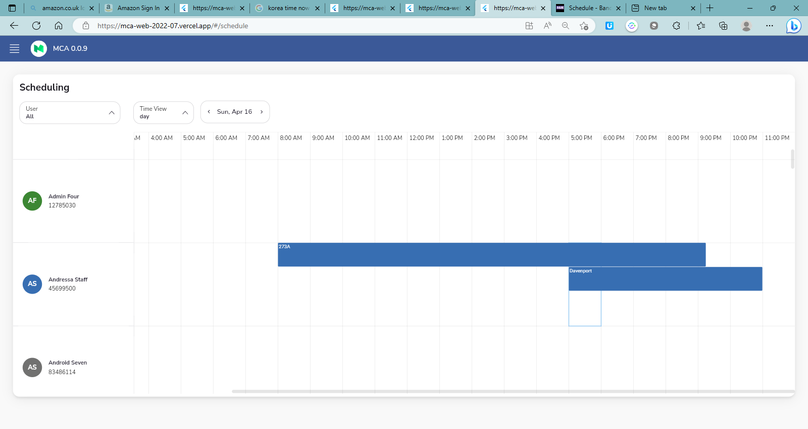

Do all users have to have the same row height, Can it be based on number of shfts?

Just spoke to Imre, I think Shift view is useful (sorry for changing)

**Month view**

Copy all is only copying 2 shifts